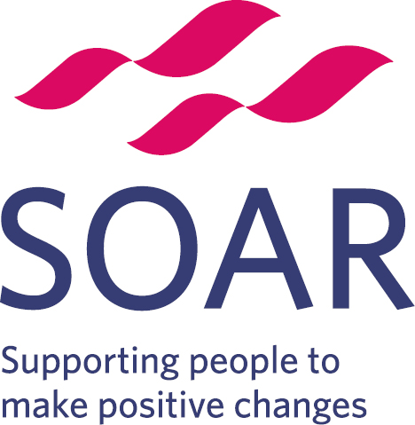 | Volunteer Role Description
Post title: Emotional Wellbeing Recovery Coach

Responsible to : Mental Health Peer Support Worker

Time commitment: 1 shift or half a shift per week. 1 shift is 4 – 5 hours

Purpose of role: To improve the health and wellbeing of people in Sheffield’s least healthy communities. You will work closely with the Mental Health Peer Support Worker to provide emotional support to suitable clients.

Social cafes are places where people meet to share food, try gentle physical exercise, play games and engage in conversation. Their purpose is to reduce social isolation and help participants find ways of supporting each other. Some social cafes are targeted at different groups such as global majority communities or men.

Location:
Burngreave – weekly on Tuesdays 1:30pm till 4pm or Shiregreen Neighbourhood centre – weekly, times and dates to be confirmed

What’s involved?
The role of the Emotional Wellbeing Recovery Coach is to…
- Introduce and welcome new participants to the Social Café through informal discussions individually or as part of small groups
- Facilitate and encourage participation in whole group discussions on recovery themes particularly by people new to Social Café
- Conduct informal constructive discussions with participants to find out where they feel they are on their recovery journey using a recognised method of assessment.
- Record the outcomes of informal discussions
- Encourage participants to identify their recovery goals and the activities which will help to achieve these
- Motivate participants to undertake activities which promote recovery through informal coaching and mentoring
- Take part in activities alongside participants to encourage participation and movement towards self-reliance
- Review progress made by participants in achieving recovery goals using a recognised method of assessment.
- Provide regular feedback to the Mental Health Peer Support Worker and other paid staff regarding successes and outstanding needs in achieving recovery goals
- Participate in the planning of Social Café sessions.

What knowledge do I need?
As an Emotional Wellbeing Recovery Coach, it would be beneficial for you to know about:
- The challenges clients may face who are engaged with the Mental Health Peer Support Project (serious mental health issues)
- Local services that clients may link in to
- The needs of your local community
- Men’s Health challenges
- Have an interest in mental health and well being

What skills do I need?
- Empathy with people recovering from mental health problems
- Ability and confidence to challenge and encourage people to make positive changes
- Ability to take ownership of situations arising and use your own initiative to complete tasks
- Understanding of the mental health recovery model or a willingness to undertake relevant training
- Good interpersonal skills
- Ability to conduct constructive informal discussions with people in recovery
- Ability to facilitate small group discussions
- Ability to use methods of measuring recovery outcomes following relevant training.
- Ability to encourage participation in by people in recovery in a range of health promoting activities within the Social Café venue and the wider community.
- Ability to work without constant supervision as part of a supportive team.

What can I gain from this role?
- Developing transferable skills
- Enhancing your CV
- Valuable experience in community-based work
- A greater awareness of services and activities in your local area
- Training in areas relevant to the role
- Opportunity to meet new people and develop your social skills
- Access to SOAR’s training and employment services.

Training
You will receive an induction and training on issues and themes relating to community health promotion including customer service. You will also receive a handbook and have access to policies and procedures, including Health & Safety and Safeguarding. Additional relevant training will be available to cover individual needs and enable you to undertake this role with confidence.

Recruitment Process
Individuals interested in the role will be required to complete an application form and have an initial chat with the Senior Wellbeing Coach at SOAR.
If you have any questions or need help filling out the form, please contact Patrick Moran -

Development
This could include expansion of personal networks, connection to community job clubs, and support from your volunteering supervisor in personal and professional development.

Support
You will be supported by a dedicated member of staff who will ensure that training and development needs are met during your time with SOAR, and provide ongoing support and supervision as needed.

Expenses
We will refund you for any reasonable expenses, such as travel and activity costs.

References
Your supervisor will go through this with you before you start. We are required to ask for two references for all roles.

For more information, please email Patrick.moran@soarcommunity.org.uk or call Patrick on 07904163331

